

Megha Sharma  
16148393  
mszzf@mail.umkc.edu

CS551 Advanced Software Engineering

Midterm: Hackathon(Take-home programming)

# Design

1. System Architecture
2. Class Diagram

# Features implemented

1. Web Services:
   1. Own Services:
   * SOAP webservice was implemented to store the route information along with the various places visited.
   * SOAP webservice was implemented to query the database for all the routes or based on the source and destination if the user enters one
   * SOAP webservice to retrieve the information for all the places in the selected route
   1. Existing services/APIs
   * Four Sqaure’s search api has been used to populate the exact address information of the place visited
   * Four Square’s explore api has been used to populate all the recommended places nearby the place being visited
   * Google’s geocoder service has been used to get the coordinates for a destination
   * Google’s way points map has been used to populate the routes connecting all the places visited by the user
   * Google map and direction service has been used to populate directions
   * Text to Speech service from tts.com has been used to read the directions
   * jQuery plugin 2.5.2 for generating ratings
2. Database:
   1. SQL Server has been used to store the data for the routes and information of all the places corresponding to the route. C# based web services have been used to query or update the database. For every update to the database, the route name is checked. If it already exists then the place information is stored corresponding to the same route number. Otherwise a new route id is generated by reading the max route id from the DB and incrementing it by 1. Also, the placeId is auto-incremented by 1 for every new place corresponding to a route.

Below is the Table Schema.

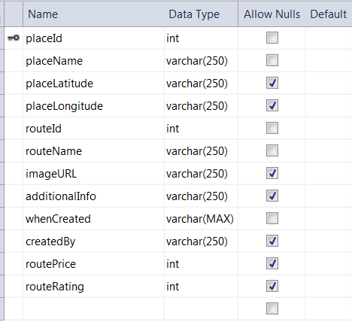

Below is the table with data updated by the app.

1. Mobile User Interface

The app can be accesed both through as a mobile client and desktop client. Twiter Bootstrap has been used to style the pages of the app.

Below is the home page of the app

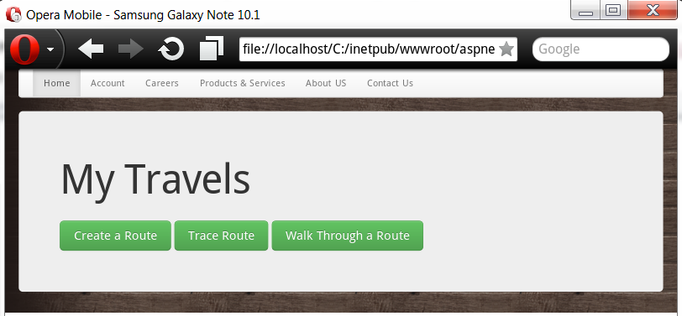

App home page with Opera Mobil

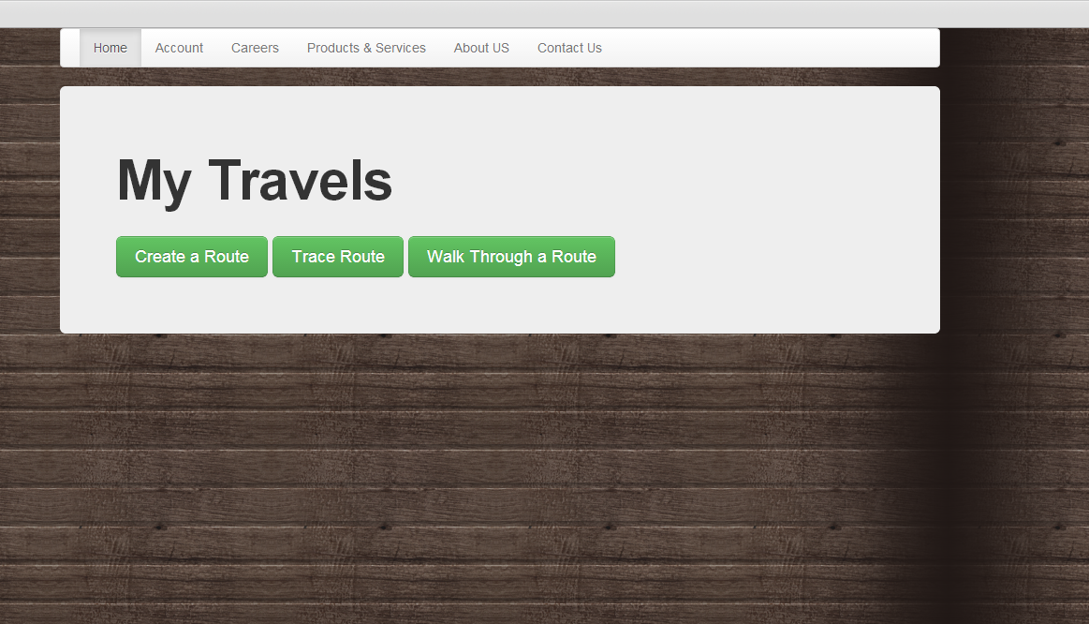

App home page with Web Client

The following features have been implemented:

1. **Create a Route**: This feature allows the user to create a route. On clicking create route, a screen shows up in which the user enters his Route Name, the place that he is visiting, additional information about the place and the image url or path.

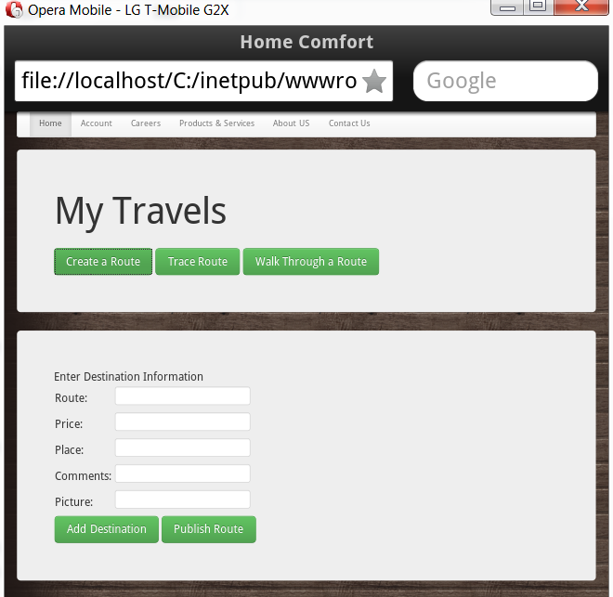

User adds the route and source information

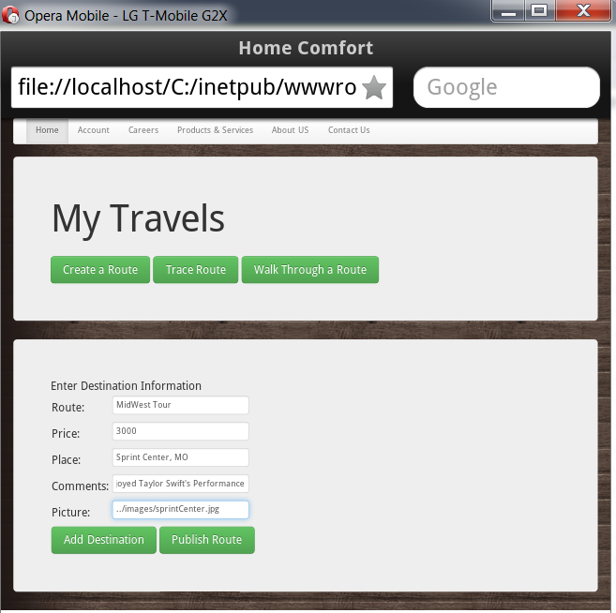

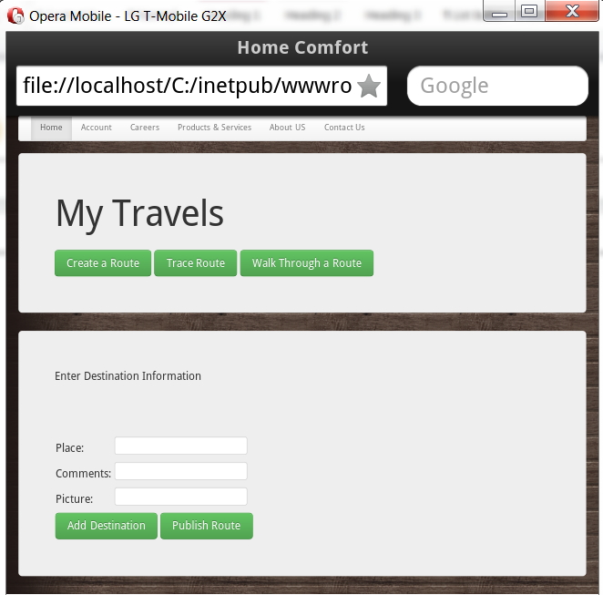

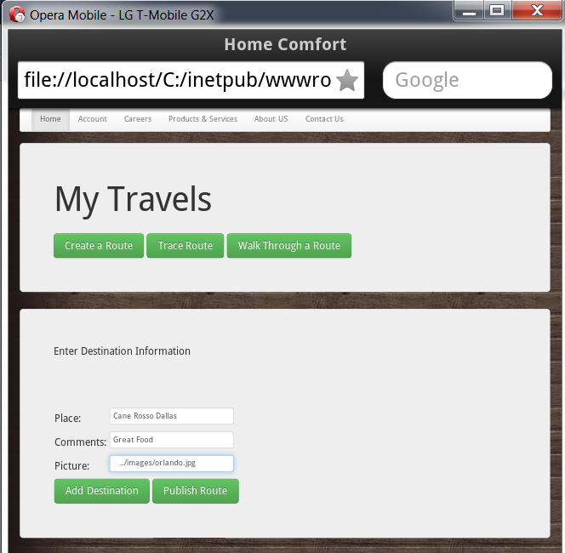

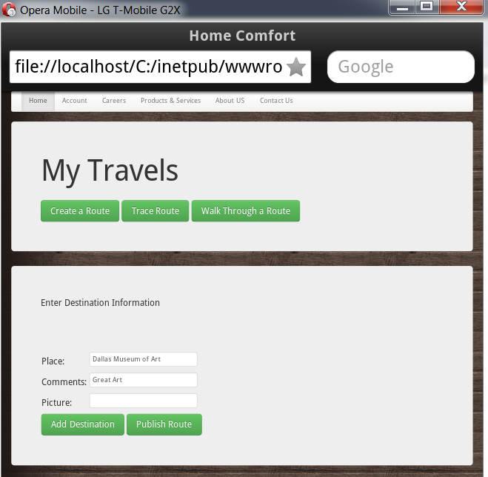

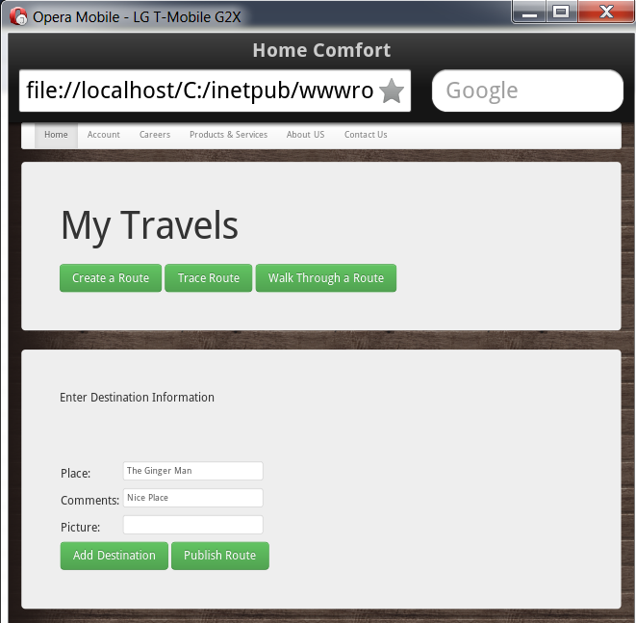

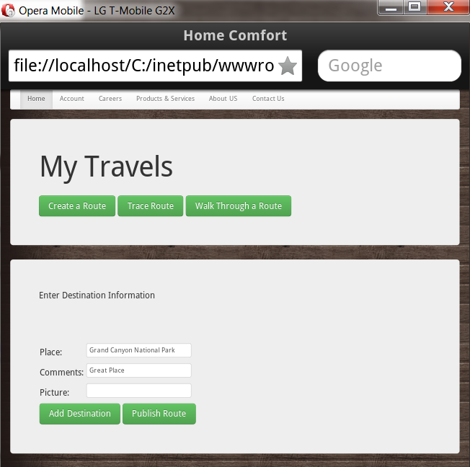

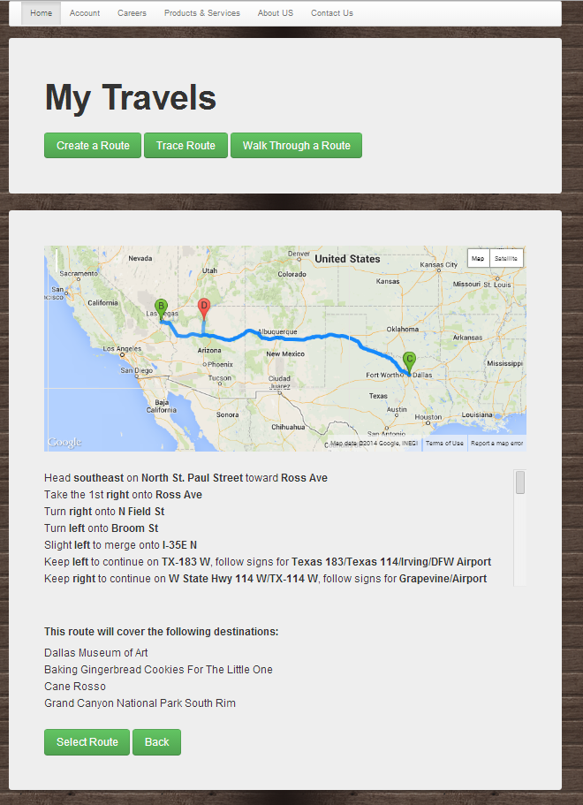

On clicking Add Place, the user gets the option to add more places to the route. For every place visited he enters the same set of information.

When the user is done visiting all the places then he clicks on Publish route which shows the entire route from source to destination with all the way points visited. He can add a price for the route. On clicking Publish route, the route name, route price along with all the place information are stored in DB.

1. **Trace Route**: In order to trace a route, the user first needs to select one.

User can enter his desired source and destination in the text box. On clicking search, all the routes with the specified source and destination along with their route name, rating and price information show up.

For the source and destination selection this feature also shows the best path which has been computed based on the price of the path and their ratings.

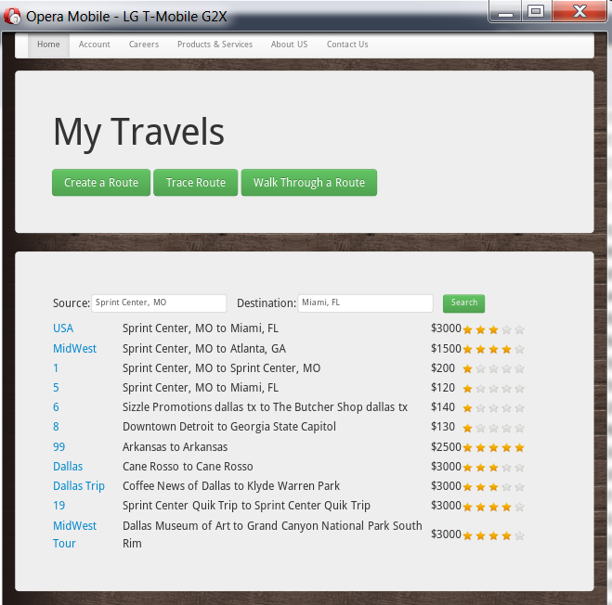

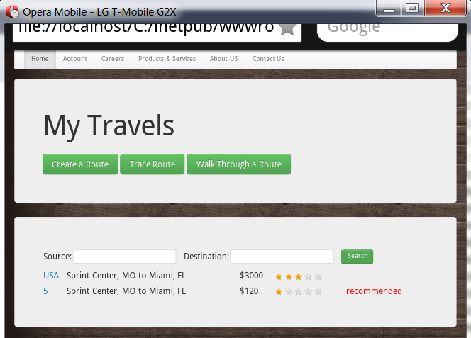

Alternatively, if the user doesn’t provide any source or destination then all the routes with their respective informations show up.

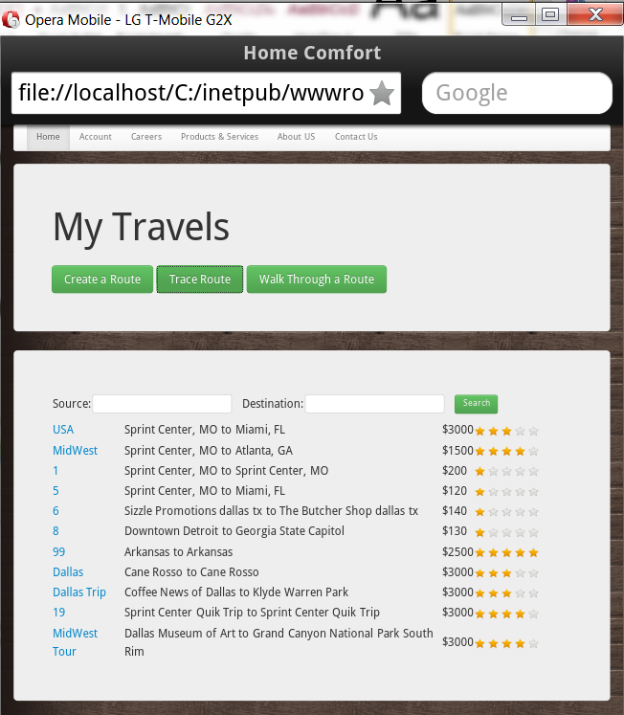

User can then select a route to trace it. On selecting a route, the user can get the route with all its way points on a google map along.He can see the directions written as well as spoken (implemented using text to speech service provided by tts).

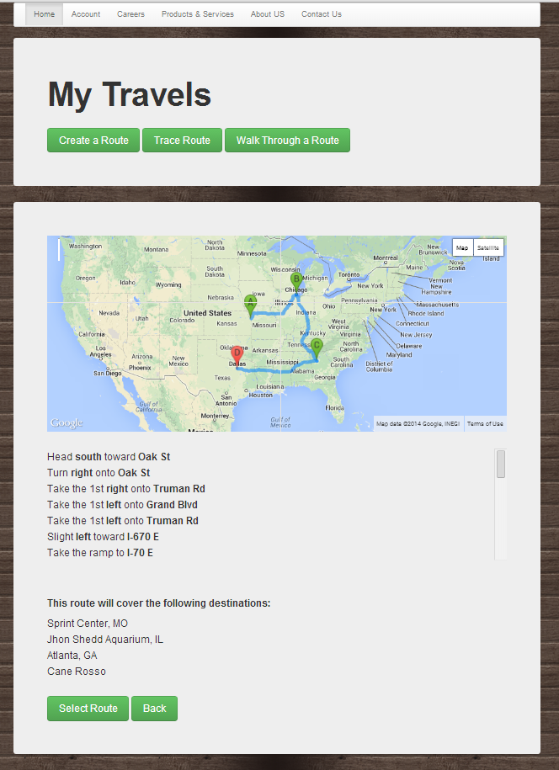

1. **Walk Through a Route:** On clicking walk the route, user sees the information about the first place (destination name, address, contact number etc), this has been populated using the Four Square api for searching a destination. On the same page he can see the pictures posted by the route’s owner and some comments about the place. On the right there is a list of recommended nearby places that the user can visit which have been populated from the Four Square API.



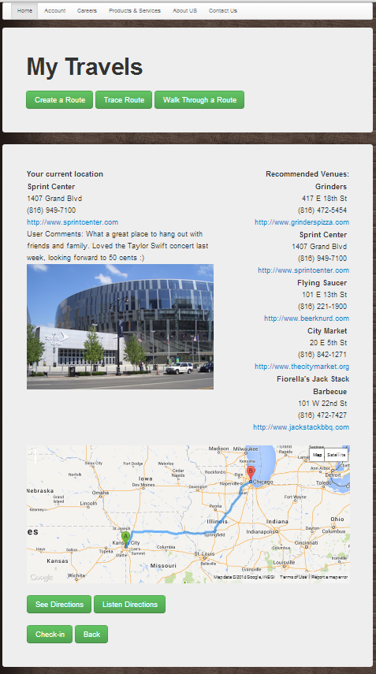

At the bottom of the screen the user can see the map for his next destination to be visited from the current destination, the directions are both written and are spoken using text to speech API.

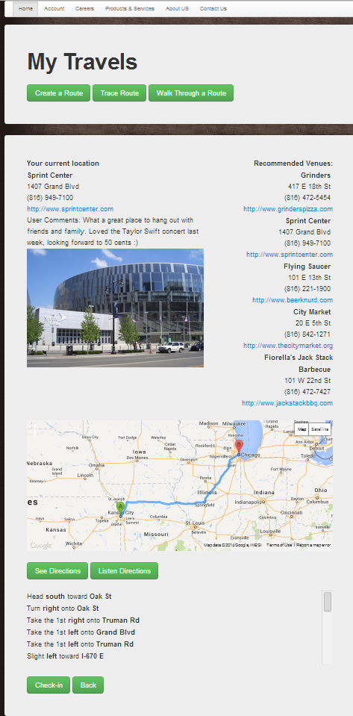

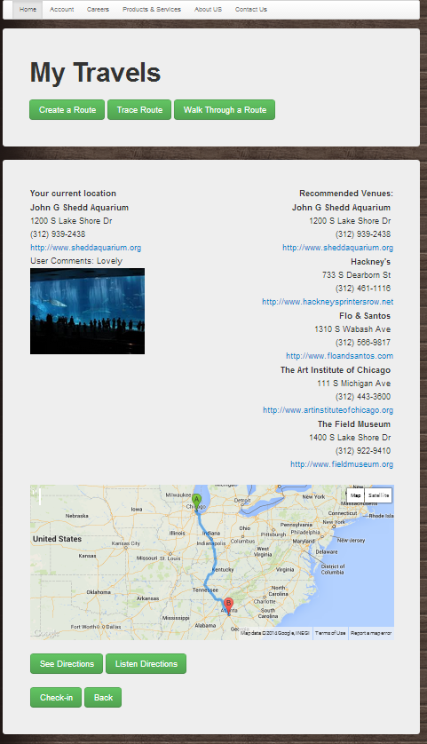

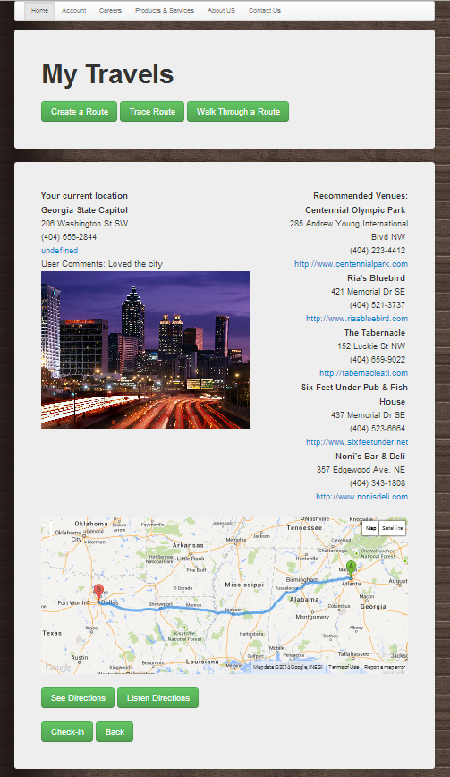

On the final destination user sees the button Done and the final destination on a map. On clicking Done, the user gets a message with an animation and an option to rate the trip.

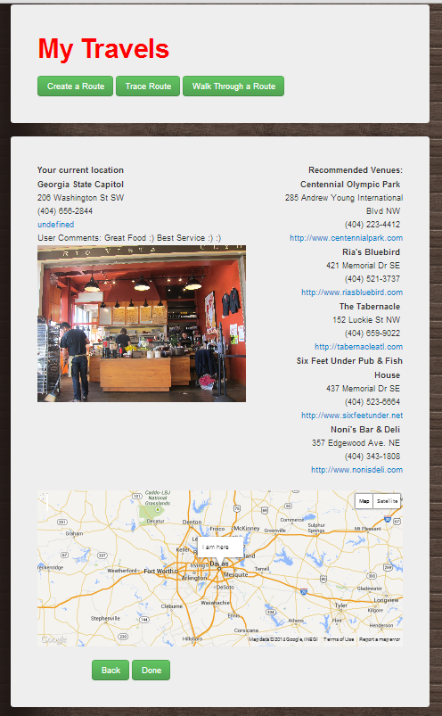

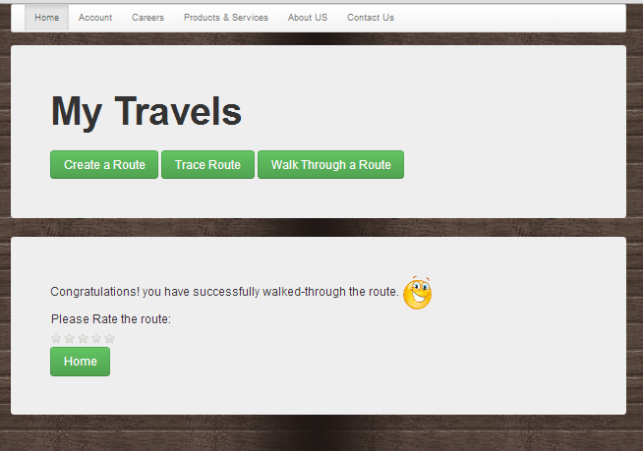

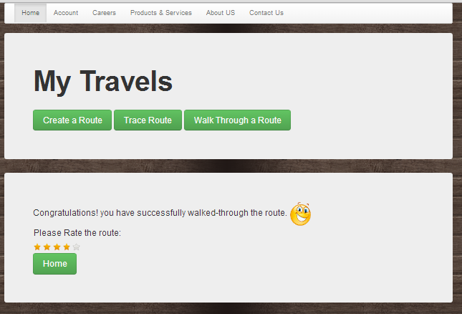

# References

Foursquare website [https://foursquare.com/](https://foursquare.com/%20)

Foursquare API <https://developer.foursquare.com/start>

Google Developer Site [https://developers.google.com/](https://developers.google.com/%20)